Tableau Testing
Functional and performance testing plan for Tableau incident dashboards
Project: ServiceNow Incident Lifecycle Automation | Phase: Development - Performance Testing

1. Purpose and Scope
This plan verifies that Tableau dashboards built on incident data show correct figures and perform well for the expected number of users and data volume.
In scope:
- Data accuracy against the ServiceNow source
- Dashboard load time, filter response and extract refresh
- Permissions and data access
- Display across supported browsers
Out of scope:
- Source data quality fixes
- Tableau Server or Cloud infrastructure tuning outside the project

2. Test Objectives
- Confirm key measures reconcile with the source.
- Confirm dashboards load and respond quickly with production-like data.
- Confirm extract refreshes complete reliably in their window.
- Confirm users only see data they are permitted to see.

3. Test Scenarios and Targets
Targets below are proposed starting points. Confirm or replace them with agreed service levels before execution.
ID | Scenario | Metric | Proposed target
TB-01 | Reconcile incident counts and averages with ServiceNow | Data accuracy | Exact match for the same period
TB-02 | Check calculated fields (MTTR, SLA compliance, backlog age) | Calculation correctness | Matches manual calculation
TB-03 | Open the main dashboard | Load time | 5 seconds or less
TB-04 | Apply filters, actions and drill-downs | Interaction time | 3 seconds or less
TB-05 | Scheduled extract refresh | Duration, success | Completes in its window; no failures
TB-06 | Concurrent users on the dashboard | Load time under load | 95th percentile within 8 seconds
TB-07 | User filters and permissions by role | Access control | Each role sees only permitted data
TB-08 | Open in supported browsers and screen sizes | Rendering | Layout correct; no clipped visuals

4. Test Approach
- Use the Tableau performance recording to find slow queries, calculations and filters.
- Compare live connection and extract modes and choose based on results.
- Test each permission role with a test account.

5. Tools
Tool / area | Use
Tableau Desktop | Performance recording and workbook checks
Tableau Server / Cloud admin views | Load times and extract refresh history
ServiceNow reports | Source of truth for reconciliation
Test accounts | Role-based access checks

6. Test Data and Environment
- Separate test project or site from production.
- Production-like data volume.
- Documented refresh schedule and data source credentials.

7. Entry and Exit Criteria
Type | Criteria
Entry | Workbook built and data source stable; reconciliation queries ready; test accounts available.
Exit | Figures match the source; load and refresh targets met; permissions verified; defects closed or accepted.

8. Risks
Risk | Mitigation
Complex calculations slow the dashboard | Move logic to the data source or extract and retest
Source data changes during testing | Use a fixed extract date
Too many filters degrade performance | Limit quick filters and use context filters where suitable

9. Results Log
ID | Scenario | Result | Pass / Fail | Notes

Process Diagram
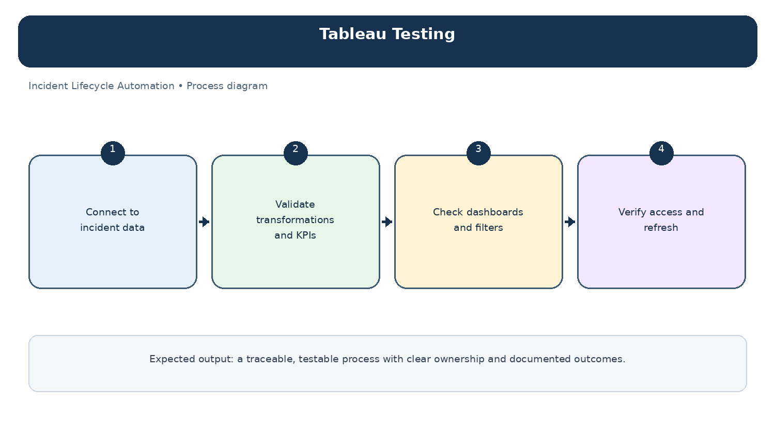
Diagram: Tableau Testing — project-specific process overview.

